B. Mitschang et al. (Hrsg.): BTW 2017 – Workshopband, Lecture Notes in Informatics (LNI), Gesellschaft für Informatik, Bonn 2017 79

**A Deep Learning-based Approach for Banana Leaf Diseases Classification**

Fanindra Maharana, N V Purna Chandar, M Sai Charan

**Abstract**

Plant diseases are important factors as they result in serious reduction in quality and quantity of agriculture products. Therefore, early detection and diagnosis of these diseases are important. To this end, we propose a deep learning-based approach that automates the process of classifying ba- nana leaves diseases. In particular, we make use of the *LeNet* architecture as a convolutional neural network to classify image data sets. The preliminary results demonstrate the effectiveness of the proposed approach even under challenging conditions such as illumination, complex background, different resolution, size, pose, and orientation of real scene images.

Keywords: Banana plant diseases, Deep learning, Classification

1. **Introduction**

Crop diseases are major sources of famine and food insecurity on our planet. In fact, it is estimated that plant pathogens may account for annual crop yield losses of up to 16% globally [Oe06]. Furthermore, the current solutions to fight different diseases demand the massive use of crop protection products, which are dangerous for the environment and the user. Microscope and DNA sequencing-based methods are effective to identify and discover different kinds of diseases. Even though many of the farmers around the world do not have access to these diagnostics tools, the vast majority of them possesses a cell phone. In fact, the Ericsson company forecasts that mobile subscriptions will reach 9.3 billion in 2019 and 5.6 billion of these will be smartphone subscriptions [Mo15]. Hence, a phone-based tool that helps in diagnosing crop diseases based on capturing and analyzing automatically a picture of a plant leaf is a promising solution.

In this paper, we take a first step towards such a tool. However, we limit our study to classify banana leaves diseases. Banana is threatened by different types of diseases, such as ***banana sigatoka***and ***banana Xanthomonas***. The black sigatoka is caused by the fungus *My- cosphaerella fijiensis*. Its symptoms start by minuscule, chlorotic spots and it then develops into thin brown streaks that are bounded by leaf veins (see Fig.1). Xanthomonas is a bacterial disease that affects banana plants, known as Banana Xanthomonas Wilt (BXW). It is caused by the bacteria Xanthomonas campestris pv. musacearum, and is also referred to as bacterial wilt.

BXW can cause significant damage to banana crops, resulting in yield losses of up to 100% if not properly controlled. The symptoms of BXW include wilting and yellowing of the leaves, and the death of the entire plant. The bacteria infect the vascular tissue of the plant, which can lead to rapid wilting and death of the plant. However, if they are diagnosed early, they can be treated and the plant can be saved.

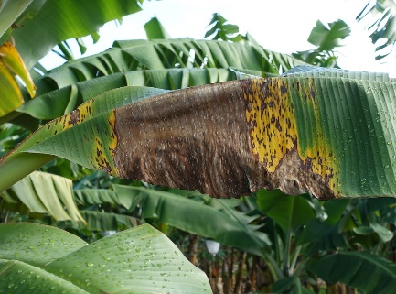 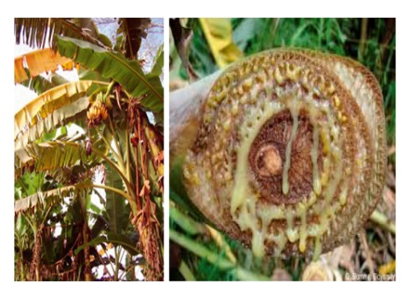

* 1. Black Sigatoka (b) Banana Xanthomonas

Figure 1: Example of two banana diseases

A system for automatically classifying and identifying banana diseases is urgently needed due to limited resources and expertise in this area. With the increasing availability of computer vision and machine learning techniques, convolutional neural networks (CNNs) have shown great promise in image classification. In this study, a new system based on CNNs was developed using the LeNet architecture, requiring minimal image preprocessing. The model was trained to recognize diseased leaves among healthy ones, with a focus on two specific types of diseases. The system was developed and tested on a computer platform. The rest of the paper is organized as follows: in Section 2, we present the related work. Section 3 explains technical details of the proposed approach and the architecture of the used convolutional neural network. Furthermore, experimental evaluation and results are reported in Section 4. Finally, Section 5 concludes the paper and provides an outlook to future work.

1. **Related Work**

In order to detect plant diseases at an early stage and prevent major production and economic losses in agriculture and forestry, there is a growing need for automated, non-destructive methods of disease detection. Recent advancements in agricultural technology have led to the use of computer vision and machine learning techniques to quickly and accurately identify plant diseases. This typically involves a multi-step process, starting with image acquisition using digital devices to capture both healthy and infected plant images. The images are then edited and prepared for analysis using techniques such as image enhancement, segmentation, color space conversion, and filtering. Image segmentation, particularly through thresholding, is commonly used to detect boundaries in images.

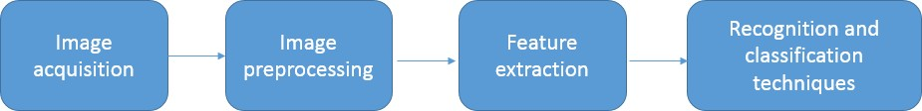

Figure 2: General steps applied to plant disease identification

After the image has been prepared, the next step is feature extraction, where features such as color, shape, and texture are calculated from the image. The final step is classification, where different algorithms such as neural network, support vector machine, and rule-based classification are used to determine whether the plant is healthy or infected. There are several state-of-the-art approaches that follow the general architecture in Fig. 2, with each approach using different techniques and algorithms for feature extraction and classification.

[Cl15] describes an automated tool for measuring foliar bleaching caused by the Corythucha ciliata (SAY) insect. The study used a CCD camera to capture images of infected plants and employed a digital color image analysis discrimination method. The RGB leaf images were converted to HIS and Lab color spaces to differentiate between healthy and infected leaves based on color variations. The method used the Otsu method to isolate the leaf from its background and detect discolorations caused by the lace bug using the chlorophyll histogram. The infected leaves were identified based on their color differences compared to the healthy leaves.

[Al11] presents a method to detect five types of leaf diseases (early scorch, cottony mold, ashen mold, late scorch, and tiny whiteness) using a color-based approach. The method begins by identifying green pixels through a global threshold calculation using the Otsu method. Once non-green pixels are removed, the infected areas are clustered using K-means technique. Texture features are then extracted using the co-occurrence matrix and fed as input to a neural network for disease identification. In [Cu10], the authors propose an automatic threshold method to differentiate between infected and healthy areas of leaves. The study utilizes a multispectral CCD camera to capture leaf images, which are then converted from RGB to HIS format. Infected and healthy pixels are segmented, and the RIA (Ratio of Infected Area) and RCI (Lesion Color Index) values are calculated. The method can determine if a leaf is healthy or not based on these values.

In [BKS16], a different approach is presented where the first step involves segmenting the leaf to eliminate the background using guided active contour. The next step involves calculating the deviation of each pixel from the green color to detect the symptoms of the disease. The greener the pixel, the healthier the part of the leaf is considered to be. The RGB space is then transformed to HSV, Lab*, and CMYK color spaces to segment the lesions and symptoms, and the classification step is performed using color histograms. Another system is introduced in [MBP16] to classify various diseases that affect paddy plants such as brown spot disease, leaf blast disease, and bacterial blight disease. In this system, the authors extract scale-invariant feature transform (SIFT) features and use KNN and SVM for classification. [Ob14] presents a prototype for the detection of fungal infections on tomato crops.

In [Sa13], the author presents an approach for identifying diseases in Phyllanthus Elegans Wall (Asin-Asin Gajah), a medical herb used for treating breast cancer. The approach involves enhancing contrast as a preprocessing step, followed by segmentation and feature extraction from images of the plant leaves. Two feed forward neural networks, namely multi-layer perceptrons and radial basis function RBF, are then applied to classify the images as either healthy or unhealthy. On the other hand, in [KAS17], the authors manually annotate a dataset of 147 images, including 31 healthy and 28 infected plant leaves, and use different color descriptors (Color Structure Descriptor (CSD), Scalable Color Descriptor (SCD), and Color Layout Descriptor (CLD)) to characterize the leaflets. The authors found that CSD produced better results compared to SCD and CLD.

Even though different methods have achieved good classification results in identifying and recognizing some of the diseases, they suffer from some limitations. Most of these methods use segmentation as the first step in analyzing the disease on a leaf. However, if the leaf is captured with a background that contains other leaves or plants, the segmentation process may be difficult and unreliable. Additionally, some disease symptoms may not have well-defined edges and can gradually fade into healthy tissue, which poses a challenge to color-based methods and thresholding. Moreover, many of these methods rely on hand-crafted features, such as color histograms, texture features, shape features, and SIFT, which can be time-consuming and require expert knowledge.

Although previous methods have shown promising results in detecting certain plant diseases, they often struggle to handle large amounts of data with significant variations. For instance, the black leaf streak disease in banana can produce diverse symptoms that are difficult to detect using traditional approaches. To address these challenges, we propose to use convolutional neural networks (CNNs) that eliminate the need for segmentation and hand-crafted features. With a substantial amount of available banana leaf data and powerful computing resources, CNNs present a feasible solution for effectively detecting and classifying plant diseases. In the next section, we detail the proposed method for banana disease identification.

# **Proposed method**

To deal with the mentioned challenges, we introduce a deep learning-based approach to classify and identify banana leaves diseases. The general architecture of the proposed framework is illustrated in Fig. 3. The figure shows that the framework consists of two main components: *image preprocessing* and *deep learning-based classification*. In the

Fol lowing, we present details about each component.

* 1. **Image preprocessing**

To prepare the dataset for analysis, the images undergo preprocessing steps. These steps involve preparing the images for analysis by removing noise, enhancing contrast, and adjusting the color balance. The images are stored in either local or global repositories and consist of both healthy and infected leaves. They were captured using a standard digital camera.

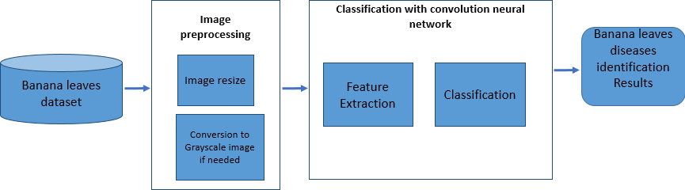

Figure 3: Proposed framework architecture.

image has three channels which are red (R), green (G), and blue (B). In our experiments we will test the applicability of our approach to both the RGB images and the grayscale images. To this end, we perform a preprocessing step where each image in our dataset is resized to 60 ⋆ 60 pixels and converted to grayscale.

* 1. **Deep learning-based classification**

Neural networks consist of several layers of interconnected neurons that learn to convert inputs into corresponding outputs. Convolutional neural networks (CNNs) are a type of neural network that have been successful in deep learning applications due to their ability to train many layers of a hierarchy in a robust manner. CNNs are particularly useful for handling low variation inputs, requiring minimal preprocessing and being able to extract relevant features while performing discrimination. The LeNet architecture is specifically used in the current implementation of the CNN for this task.

The CNN consists of three main parts as illustrated in Fig. 4: convolution, pooling, and fully connected layers. The convolution and pooling layers work together to automatically extract features from the input images, while the fully connected layer acts as a classifier to classify the images into predefined categories using the extracted features. The convolutional layer extracts features by convolving a filter over the input image and producing a feature map. The pooling layer reduces the dimensionality of the features obtained from the convolutional layer by summarizing the output of adjacent neurons. The final fully connected layer applies a softmax activation function to the high-level features learned by the model to classify the input images. The LeNet model consists of two main components: the first component is responsible for feature extraction and the second component performs image classification. In the following section, we will provide a more detailed explanation of these two components.

* + 1. **Feature extraction model**

The feature extraction component of the network is responsible for detecting high-level features from the input images, and it is comprised of a series of convolution and pooling layers.

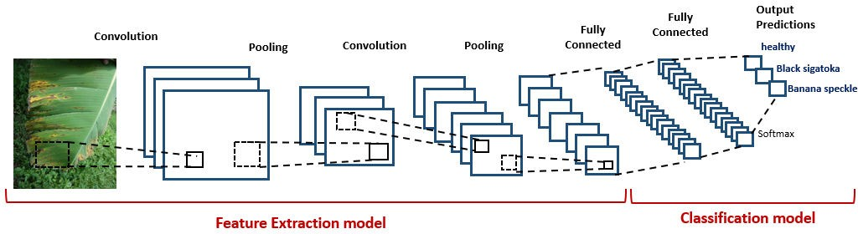

Figure 4: A graphical depiction of a LeNet mode

The feature extraction model is a crucial part of a convolutional neural network (CNN) that learns to identify and extract meaningful features from the input images. This process is achieved through a sequence of convolutional and pooling layers. The convolutional layers use a set of filters to convolve over the input image, producing feature maps that highlight different features present in the image. The pooling layers then down sample the feature maps, reducing their dimensions while preserving the most important information. This process is repeated multiple times to extract increasingly complex and abstract features from the input image. The final output of the feature extraction model is a set of high-level features that are used in the classification model to classify the input image into a predefined class.

* In the CNN architecture, the convolution layer is an essential component responsible for extracting features from the input image. It consists of a set of learnable filters that are applied to the raw pixel values of the image, taking into account the RGB color channels. The filter and input pixels are multiplied together in a sliding window fashion, resulting in a 2-dimensional activation map called a feature map. During the training process, the network learns to recognize different features from the input by adjusting the filter values. The convolution layer is defined by the number of convolutions maps it contains and the size of the filters used. The calculation for each feature map is determined by a specific equation:

*Mi* = *bi* + ∑*Wik* ⋆ *Xk* (1)

*k*

where ⋆ is the convolution operator, *Xk* is the *kth* input channel, *Wik* is the sub kernel of that channel and *bi* is a bias term. In other words, the convolution operation being performed for each feature map is the sum of the application of *k* different 2D squared convolution features plus a bias term. Hence, In comparison with traditional image feature extraction that relies on crafted general feature extractors (SIFT, Gabor filter, etc), the power of CNN is noted in its ability to learn the weights and biases of different feature maps which lead to task specific powerful feature extractors. Moreover, the rectified nonlinear activation function *(ReLU)* is performed after every convolution to introduce nonlinearity to the CNN. The ReLU is a very popular activation function which is defined as *f* (*x*) = *max*(0, *x*) where *x* is the input to a neuron.

* Max-pooling map: In the architecture of convolutional neural network, convolution layers are followed by sub-sampling layers. Each sub-sampling layer reduces the size of the convolution maps, and introduces invariance to (low) rotations and translations that can appear in the input. A layer of max-pooling is a variant of such layer that has shown different benefits in its use. The output of max-pooling layer is given by the maximum activation value in the input layer over sub windows within each feature map. The max-pooling operation reduce the size of the feature map.
  1. **Classification model**

Within the classification step the LeNet model employs fully connected layers where each neuron establishes a complete connection to all the feature maps learned from the previous layer in the CNN. These connected layers use the SoftMax activation function to compute scores for different classes. The input to the SoftMax classifier is a feature vector derived from the learning process, and the output is a probability that an image belongs to a certain class. The SoftMax function, denoted by ς, receives a C-dimensional vector z as input and generates a C-dimensional vector y with real values ranging from 0 to 1. This function can be expressed mathematically as follows:

*yc* = ς(z)*c* =

*ezc*

*C z*

*f or c* = 1 · · ·*C* (2)

∑*d*=1 *e d*

In the next section, we will present the conducted experiments and results.

# Experimental Evaluation

In order to evaluate the effectiveness of our proposed method, we carried out several experiments using a real-world dataset of banana diseases that was obtained from the PlantVillage initiative. This dataset comprises thousands of images of crop plants, both healthy and diseased, which are publicly available online. The dataset we used contained images classified into three categories: healthy plants (1643 images), plants with black sigatoka disease (240 images), and plants with black speckle disease (1817 images). Fig. 1 shows some sample images from the dataset, which in total contains 3700 images with varying sizes, orientations, poses, backgrounds, and lighting conditions. For our implementation, we utilized the deeplearning4j library, an open-source deep learning tool that supports the use of GPUs to speed up the execution of deep learning algorithms.

Our aim is to assess how well our model performs in predicting banana diseases on new data that was not used during training. To achieve this, we conducted experiments using various train and test set splits to test the robustness of our algorithm and its ability to avoid overfitting. This involved using a certain percentage of the entire dataset for training, and the remaining for testing. We varied the percentage of the training dataset from 20% to 80% while using the same set of hyperparameters, which were determined through a series of empirical experiments on the whole dataset to achieve the best classification results.

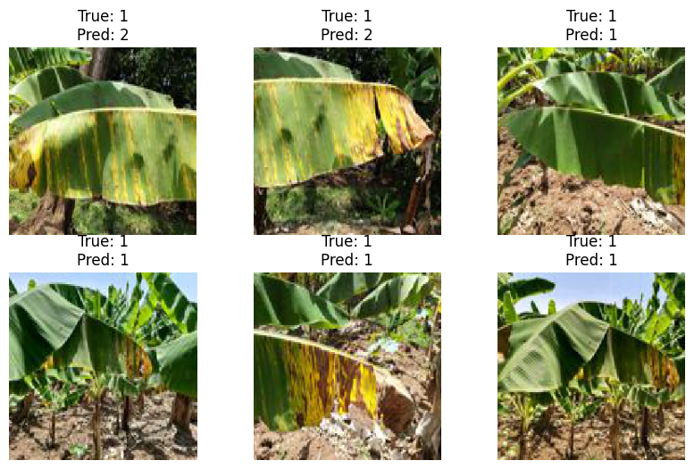

these results were obtained using our deep learning model for identifying three banana images classes (healthy, black sigatoka and Banana Xanthomonas). As shown in the above figure, our model was able to find good results when applied to classify the diseases of banana from its leaves. The obtained results confirm the the importance of the color information in plant disease identification. Hence, a green color always refers to a healthy leaf while a leaf with black or brown spots may be considered unhealthy.

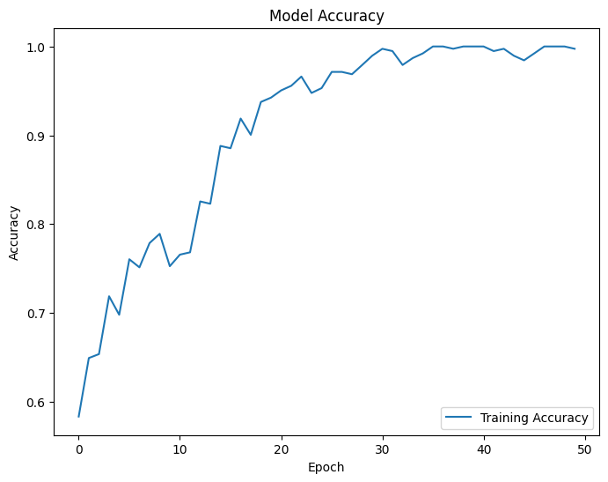

Figure 5: Comparison of progression of overall accuracy grouped by train-test set splits

Fig. 5 shows the accuracy of the different train and tests splits choices while the number of iterations is varied. As we can see, in some splits the model take more time to con- verge. However, in most of the test splits, the model starts to stabilize from iteration 30 and achieve good accuracy at the final iteration.

# **Conclusion**

The agricultural industry faces a major issue of plant diseases, which have a negative impact on crop yield and quality. In addition, the lack of diagnostic tools in less developed countries significantly affects their progress and standard of living. Therefore, it is crucial to detect plant diseases early on through cost-effective and user-friendly solutions. In this study, we introduced a convolutional neural network-based approach for identifying and categorizing banana diseases. Our model can be utilized as a tool to assist farmers in identifying diseases in banana plants.

Hence, the proposed system enables farmers to identify banana diseases by simply taking a picture of the affected leaf. Our main contribution is the application of deep neural networks to identify two common banana diseases, namely banana sigatoka and banana Xanthomonas, under various challenging conditions such as complex background, different image resolution, size, pose, and orientation. The system demonstrated good classification results after several experiments, indicating that it can accurately detect leaf diseases with minimal computational effort. In future work, we plan to expand our model to include more plant diseases and automatically estimate the severity of the detected disease, which can aid farmers in making informed decisions on disease intervention strategies.

# Acknowledgments

We are grateful to Birgitta Ko¨nig-Ries for their discussions and their technical supports. A part of this research was supported by The DAAD funding through the BioDialog project.

A. Algergawy’work is partly funded by DFG in the INFRA1 project of CRC AquaDiva.

# References

[Al11] Al-Hiary, H.; Bani-Ahmad, S.; Reyalat, M.; Braik, M.; ALRahamneh, Z.: Fast and ac- curate detection and classification of plant diseases. International Journal of Computer Applications, 17(1):0975–8887, 2011.

[ARK10] Arel, Itamar; Rose, Derek C.; Karnowski, Thomas P.: Deep Machine Learning - A New Frontier in Artificial Intelligence Research [Research Frontier]. IEEE Comp. Int. Mag., 5(4):13–18, 2010.

[Ba16] Barbedo, A.: A review on the main challenges in automatic plant disease identification based on visible range images. Biosystems Engineering, 144:52–60, 2016.

[BKS16] Barbedo, Jayme Garcia Arnal; Koenigkan, Luciano Vieira; Santos, Thiago Teixeira: Iden- tifying multiple plant diseases using digital image processing. Biosystems Engineering, 147:104–116, 2016.

[Cl15] Clement, Alain; Verfaille, T; Lormel, C; Jaloux, B: A new colour vision system to quantify automatically foliar discolouration caused by insect pests feeding on leaf cells. Biosystems Engineering, 133:128–140, 2015.

[Cu10] Cui, Di; Zhang, Qin; Li, Minzan; Hartman, Glen L.; Zhao, Youfu: Image processing meth- ods for quantitatively detecting soybean rust from multispectral images. Biosystems En- gineering, 107(3):186–193, 2010.

[De14] Deng, Li: A tutorial survey of architectures, algorithms, and applications for deep learn- ing. APSIPA Transactions on Signal and Information Processing, 3, 2014.

[HS15] Hughes, David P.; Salathe´, Marcel: An open access repository of images on plant health to enable the development of mobile disease diagnostics through machine learning and crowdsourcing. CoRR, abs/1511.08060, 2015.

[Le89] LeCun, Yann; Boser, Bernhard; Denker, John S; Henderson, Donnie; Howard, Richard E; Hubbard, Wayne; Jackel, Lawrence D: Backpropagation applied to handwritten zip code recognition. Neural computation, 1(4):541–551, 1989.

[MBP16] Mohan, K. Jagan; Balasubramanian, M.; Palanivel, S.: Detection and Recognition of Dis- eases from Paddy Plant Leaf Images. International Journal of Computer Applications, 144(12):34–41, 2016.

[MHS16] Mohanty, Sharada Prasanna; Hughes, David; Salathe, Marcel: Using Deep Learning for Image-Based Plant Disease Detection. 2016.

[Mo15] Mobility, Ericsson: , Interim Update: Ericsson Mobility Report, 2015.

[Ob14] Oberti, Roberto; Marchi, Massimo; Tirelli, Paolo; Calcante, Aldo; Iriti, Marcello; Borgh- ese, Alberto N.: Automatic detection of powdery mildew on grapevine leaves by image analysis: Optimal view-angle range to increase the sensitivity. Computers and Electronics in Agriculture, 104:1–8, 2014.

[Oe06] Oerke, E-C: Crop losses to pests. The Journal of Agricultural Science, 144(01):31–43, 2006.

[PC13] Patil, Sagar; Chandavale, Anjali: A Survey on Methods of Plant Disease Detection. In- ternational Journal of Science and Research (IJSR), 6(14), 2013.

[Sa13] Sannakki, Sanjeev S; Rajpurohit, Vijay S; Nargund, V B; Kulkarni, Pallavi: Diagnosis and Classification of Grape Leaf Diseases using Neural Networks. In: Fourth International Conference on Communications and Networking Technologies. 2013.

[Sc16] Schor, Noa; Bechar, Avital; Ignat, Timea; Dombrovsky, Aviv; Elad, Yigal; Berman, Si- gal: Robotic Disease Detection in Greenhouses: Combined Detection of Powdery Mildew and Tomato Spotted Wilt Virus. IEEE ROBOTICS AND AUTOMATION LETTERS, 1(1):354–360, 2016.